Software engineering for big data analaysis

CSA-1035

EXP NO:- 2

1. Draw a use case diagram for Library Management System is an automation system used to manage a library and the different resource management required in it like cataloguing of books, allowing check out and return of books, invoicing, user management, etc. The user can search for book details using a few book properties (Book ID, Title, Author, and Publisher). Searching should return details about all the book copies that match the search query.

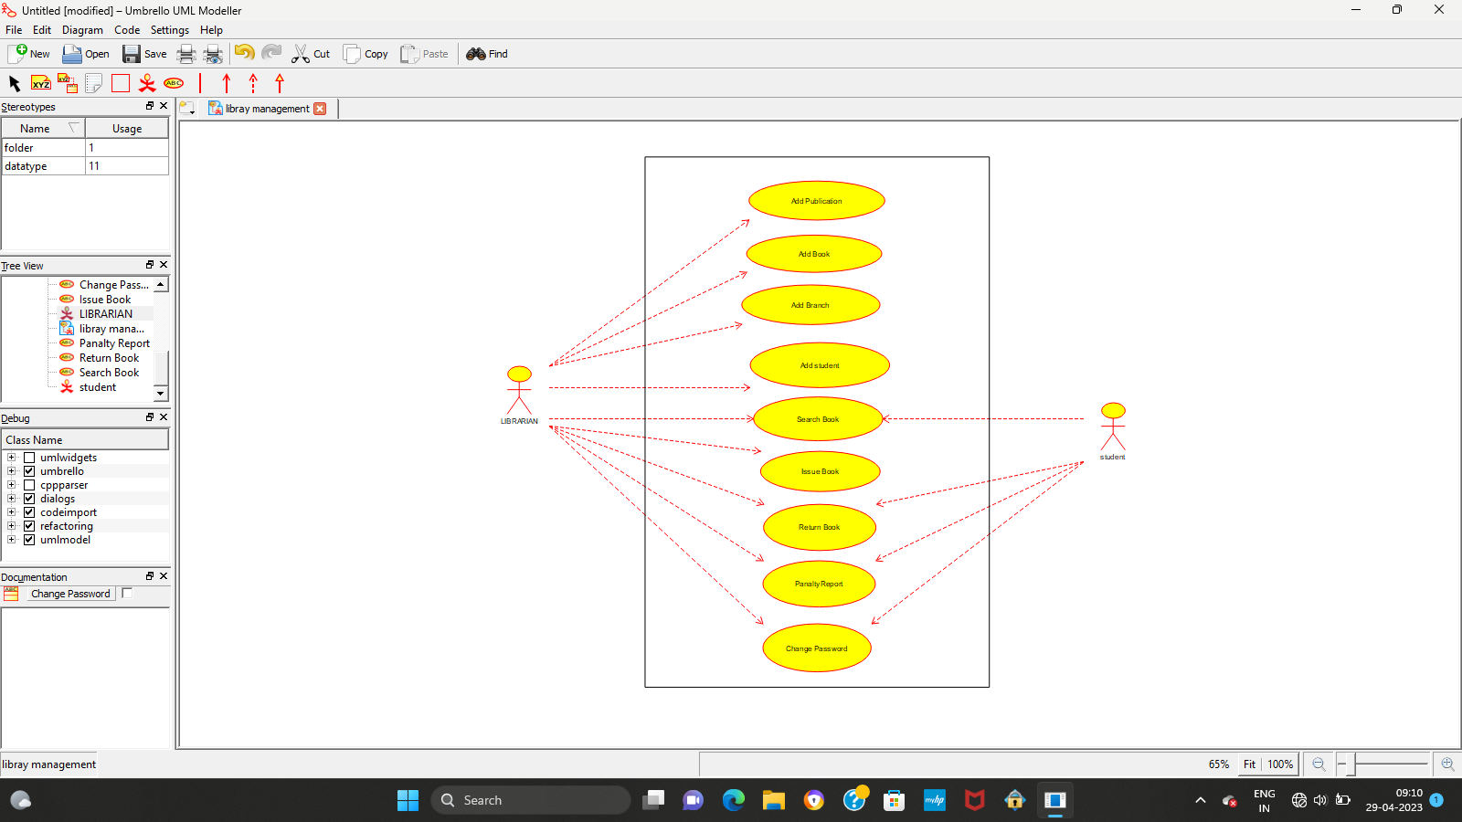

RESULT:-

Thus the use-case diagram for libray management is drawn and verified successfully.